James Young Take Home Test 2/7/2018

**\*All plots and tables were created using RStudio (code in Appendix A)**

**A. Write the analysis of variance model for this study, and define each term in the model.**

$$y_{ij}=μ+τ_{i}+ε_{ij},$$

Where $y_{ij}$ = jth observed sample value from the ith population, 𝜇 = reference value (overall mean) $τ_{i}$ = effect of an observation being in the ith population which is the difference between the mean of the ith population and the reference value (that is, 𝜇i – 𝜇), and $ε_{ij},$ = difference (deviation, residual) of the jth observed value from its respective population mean.

**B. State the assumptions necessary for an analysis of variance of the data and verify the assumptions**

1. The specified model and its parameters adequately represent the behavior of the data

2. The ’s are normally distributed random variables with mean zero and common variance .

A close up of a map

Description generated with high confidence3. The $ε_{ij}$’s are independent in the probability sense (the value of one $ε_{ij}$ does not affect another $ε_{ij}$).

Looking at the qqline plot, residuals seem

normally distributed throughout the

quartiles and amongst the line.

Shapiro-Wilk Test (with )

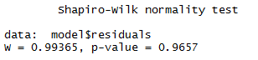H0 : All residuals came from normal distribution

H1: Any residuals did not come from a normal distribution

Decision: Calculate p-value = 0.9657. 0.9657 > 0.01 therefore

we fail to reject H0 and conclude the residuals are normal.

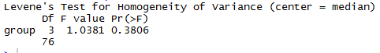Levene’s Test (with )

H0:

H1 : variance are not all equal

Decision: Calculate p-value = 0.3806. 0.3806 > 0.05, therefore

we fail to reject H0 and conclude the variance are normal.

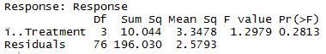**C. State the hypothesis and compute the analysis of variance table for the data.**

$$H_{0}:µ_{1}=µ_{2}=µ_{3}=µ_{4}$$

$$H_{1:} means are not all equal$$

**D. Test the hypothesis of no difference among the means with α = 0.05. State your decision with respect to the null hypothesis and give a conclusion in the context of this scenario.**

The calculated F value (taken from ANOVA table above) is 1.2979. The F value at α = 0.05 and 3 degrees of freedom in the numerator and 76 degrees of freedom in the denominator is 2.73 $≤$ 2.70. 1.2979 < 2.70, therefore we fail to reject H0 and conclude there is no significant difference between means. None of the groups provided any significantly advantageous response, so we should not recommend any of the treatments used in this test.

**E. The researcher stated before the experiment that the control would be compared to the average of the other three treatments. Give the contrast for this comparison, the hypotheses, and perform the appropriate analysis with α = 0.05. State your decision with respect to the null hypothesis and give a conclusion in the context of this scenario.**

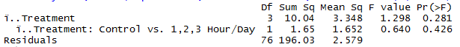H0 : L1 = 0

H1 : L1

where

L1 =

The calculated F value for contrast L1 is 0.640. The F value at α = 0.05 with 1 degree of freedom in the numerator and 76 degrees of freedom in the denominator is 3.97 $≤$ 3.94. 0.640 < 3.94, therefore we fail to reject H0 and conclude there is no significant difference between $µ_{1}$ and $\frac{µ_{2}+µ_{3}-µ_{4}}{3}$. The treatments with the medical device do not confer a recovery advantage relative to the control based upon this analysis.

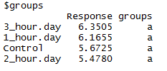**F. Perform a Duncan’s multiple-range test on the four treatments. Give the hypotheses and explain your results.**

H0= when i

H1= when i

Duncan’s multiple-range test showed all treatments in group “a”. This means none of the treatments had a response score strong enough to be in its own group. I interpret this as confirmation of the ANOVA and contrast which show there is not a significant improvement between the treatment and the control.

Appendix A -R Code

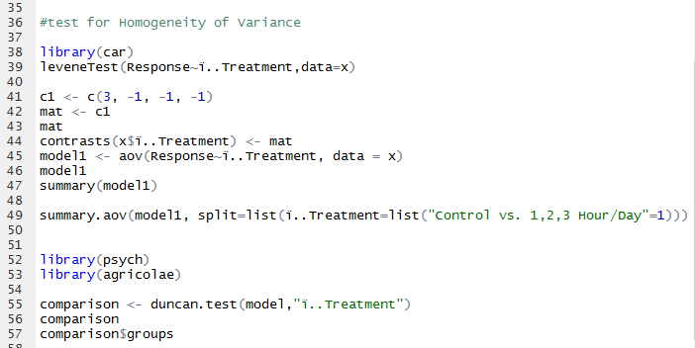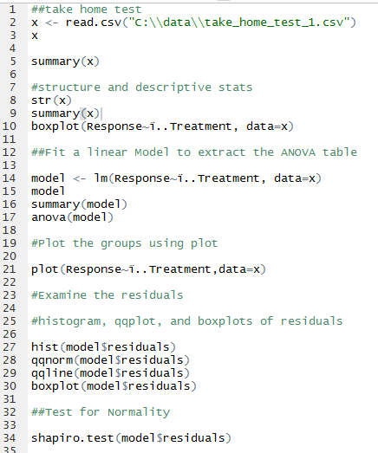

Appendix B – Dataset

|  |  |
| --- | --- |
| (**Formatted to fit page)**  Treatment | Response |
| Control | 4.51 |
| Control | 7.95 |
| Control | 4.97 |
| Control | 3 |
| Control | 7.97 |
| Control | 2.23 |
| Control | 3.95 |
| Control | 5.64 |
| Control | 9.35 |
| Control | 6.52 |
| Control | 4.96 |
| Control | 6.1 |
| Control | 7.19 |
| Control | 4.03 |
| Control | 2.72 |
| Control | 9.19 |
| Control | 5.17 |
| Control | 5.7 |
| Control | 5.85 |
| Control | 6.45 |
| 1_hour.day | 5.32 |
| 1_hour.day | 6 |
| 1_hour.day | 5.12 |
| 1_hour.day | 7.08 |
| 1_hour.day | 5.48 |
| 1_hour.day | 6.52 |
| 1_hour.day | 4.09 |
| 1_hour.day | 6.28 |
| 1_hour.day | 7.77 |
| 1_hour.day | 5.68 |
| 1_hour.day | 8.47 |
| 1_hour.day | 4.58 |
| 1_hour.day | 4.11 |
| 1_hour.day | 5.72 |
| 1_hour.day | 5.91 |
| 1_hour.day | 6.89 |
| 1_hour.day | 6.99 |
| 1_hour.day | 4.98 |
| 1_hour.day | 9.94 |
| 1_hour.day | 6.38 |
| 2_hour.day | 4.73 |
| 2_hour.day | 5.81 |
| 2_hour.day | 5.69 |
| 2_hour.day | 3.86 |
| 2_hour.day | 4.06 |
| 2_hour.day | 6.56 |
| 2_hour.day | 8.34 |
| 2_hour.day | 3.01 |
| 2_hour.day | 6.71 |
| 2_hour.day | 6.51 |
| 2_hour.day | 1.7 |
| 2_hour.day | 5.89 |
| 2_hour.day | 6.55 |
| 2_hour.day | 5.34 |
| 2_hour.day | 5.88 |
| 2_hour.day | 7.5 |
| 2_hour.day | 3.28 |
| 2_hour.day | 5.38 |
| 2_hour.day | 7.3 |
| 2_hour.day | 5.46 |
| 3_hour.day | 7.03 |
| 3_hour.day | 4.65 |
| 3_hour.day | 6.65 |
| 3_hour.day | 5.49 |
| 3_hour.day | 6.98 |
| 3_hour.day | 4.85 |
| 3_hour.day | 7.26 |
| 3_hour.day | 5.92 |
| 3_hour.day | 5.58 |
| 3_hour.day | 7.91 |
| 3_hour.day | 4.9 |
| 3_hour.day | 4.54 |
| 3_hour.day | 8.18 |
| 3_hour.day | 5.42 |
| 3_hour.day | 6.03 |
| 3_hour.day | 7.04 |
| 3_hour.day | 5.17 |
| 3_hour.day | 7.6 |
| 3_hour.day | 7.9 |
| 3_hour.day | 7.91 |